Requirement Analysis

Group ICT1.K62.20201-09

* Trần Lê Hoàng
* …

# Use case diagram

## General use case diagram

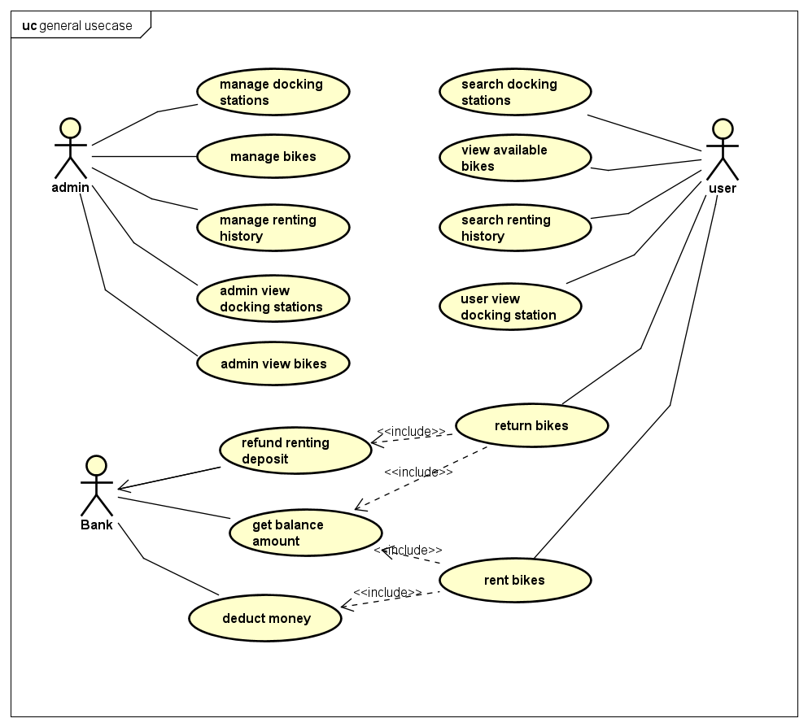

## Use case diagram for “Manage bikes”

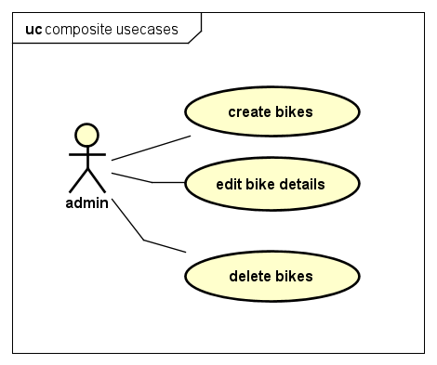

# Use case specification

## Use case “Edit bikes detail”

|  |  |  |  |
| --- | --- | --- | --- |
| UC Code | UC001 | Use case name | Edit bike details |
| Actor | Admin | | |
| Description | The “edit bike details” use case is initiated when admin press edit button in the bike detail page. Subsequently, a new page with title “Update bike details” appears containing current information about the selected bike. Admin can then edit each individual fields. The page can be dismissed by clicking either “Save” or “Cancel” button. Pressing “Save” button will result in the entry of selected bike be updated to reflect changes, while “Cancel” button made no changes to that bike | | |
| Precondition | Admin successful Login | | |
| Main flow of event (success) | | # | Doer | Action | | --- | --- | --- | |  | Admin | Choose edit bike button in bikes page | |  | Software | displays admin edit bike screen | |  | Software | Update details in edit screen with selected bike | |  | Admin | enters bike details to update | |  | Admin | Choose save bike button | |  | Software | checks if the entered detail fields is valid | |  | Software | Save updated bike if details is valid | |  | Software | Displays successfully update bike detail message | |  | Software | Close edit page and return to bike list page | | | |
| Alternative flow of event | |  |  |  | | --- | --- | --- | | # | Doer | Action | |  | Admin | Cancels edit page at any time | | 4a | Admin | Clears any field before saving | | 5b | Admin | Choose cancel button | | 6a. | Software | Notifies error “Invalid field input” if the entered detail field is invalid, go to step 2 | | 6b | Software | Notifies information “No field change” if nothing is edited, go to step 2 | | | |
| Post condition | No | | |

* Bike edit input requirements:

|  |  |  |  |  |  |
| --- | --- | --- | --- | --- | --- |
| **#** | **Data field** | **Description** | **Required?** | **Valid condition** | **Example** |
| 1. | Name | The name of this bike | Yes | Characters and numbers only | Eco Bike |
| 2 | Type | The bike’s type | Yes | Characters and numbers only | EBike |
| 3 | Weight | The bike’s weight (in kilograms) | Yes | Numbers only | 30 |
| 4 | License Plate | The bike’s license series | Yes | Characters and numbers only | ECOB12345 |
| 5 | Manufacturing Date | The bike’s manufacturing date | Yes | Check for valid date format | 12/10/2015 |
| 6 | Producer | The bike’s producer company | Yes | Characters and numbers only | Thong Nhat |
| 7 | Cost | The bike’s cost | Yes | Currency format | 10.000.000 |